INTERNET OF THINGS (IOT) PROJECTS USING PYTHON

(IOTPP – CSE 4110)

Submitted By

Name of Student | Bali Babu Chauhan
Registration No. | 19410121182
Semester | 7th
Branch (Section) | CSE-M

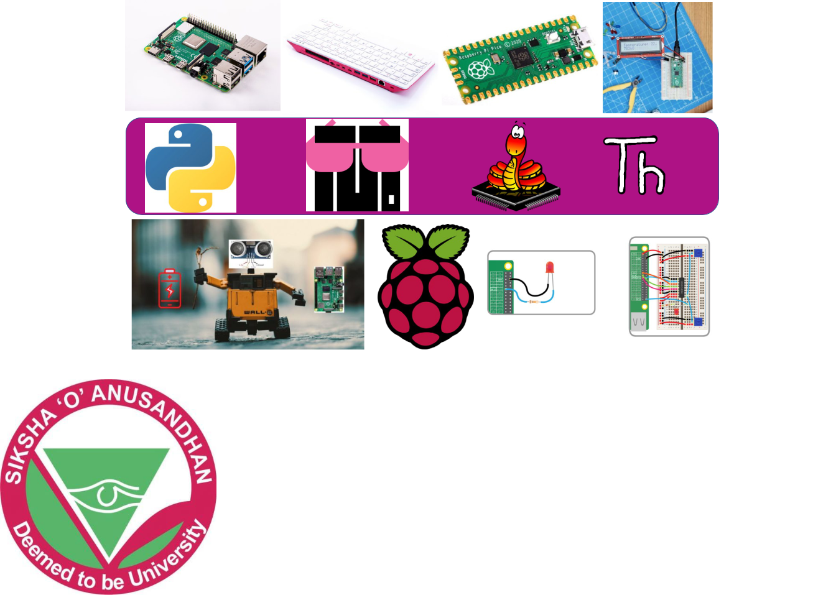

DEPARTMENT OF COMPUTER SCIENCE AND ENGINEERING Institute of Technical Education and Research Faculty of Engineering and Technology SIKSHA ‘O’ ANUSANDHAN DEEMED TO BE UNIVERSITY Bhubaneswar, Odisha, India

